Titanic Survival Analysis: Key Influencing Factors and the Role of Lift
So according to my code and the output I got, after using association rule mining with the Apriori algorithm on Titanic passenger data, I observed several key patterns that shed light on the factors influencing survival. The rules with the highest lift values revealed to me that female passengers, particularly adults in 1st and 2nd class, were significantly more likely to survive. For example, the rule {'Class_1st', 'Sex_Female'} => {'Survived_Yes'} had a confidence of 0.972 and a lift of 3.010, indicating that this group had a survival rate nearly three times higher than average. Similarly, children in 2nd class also showed strong survival likelihoods, with a confidence of 1.000 and a lift of 3.096. But if we look at male passengers, especially adult males in 2nd and 3rd class, were overwhelmingly associated with non-survival, shown by rules like {'Sex_Male', 'Class_3rd'} => {'Survived_No'} (confidence: 0.827, lift: 1.222). And this tracks because from what I remember from seeing the movie "Titanic", it is true that priority was given to “women and children first”, particularly from higher classes, due to limited lifeboats.
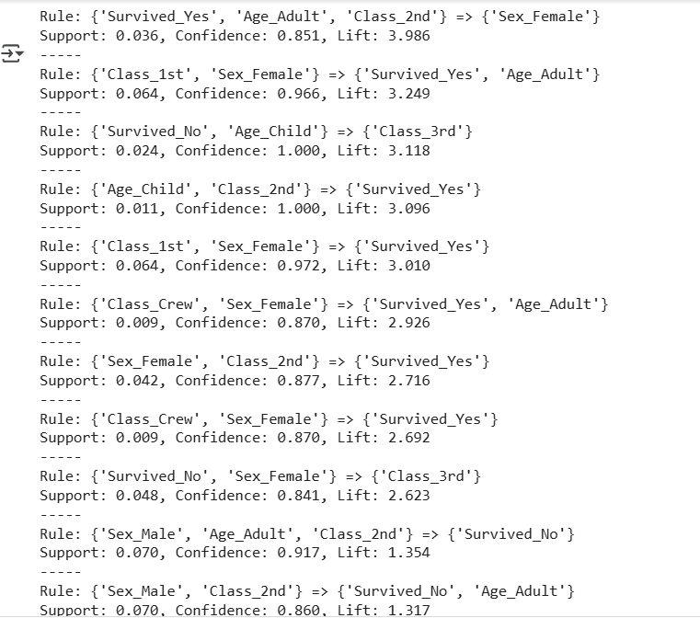
The lift metric was essential for us in highlighting rules that are not just statistically frequent, but also meaningfully stronger than chance. Rules with high confidence but low lift (close to 1.0) often involved general traits like Age_Adult, which although common, didn’t provide deeper insights into survival likelihood. Lift helped us to isolate truly interesting relationships, such as combinations of sex and class that strongly impacted survival. It allowed us to go beyond surface-level patterns and focus on disproportionately affected groups, which is crucial in understanding the human factors behind the tragedy.

